**ROLE : DATA ANALYST**

**TOPIC : AMAZON SALES**

Github : https://github.com/nayakpratham8079/Innobyte-Services.git

Linkdln : www.linkedin.com/in/pratham-nayak-3345a3263

**TABLE OF CONTENT**

|  |  |
| --- | --- |
| 1 | INTRODUCTION |
| 2 | OBJECTIVES |
| 3 | DATA PREPARATIONS |
| 4 | SALES ANALYSIS |
| 5 | PRODUCT ANALYSIS |
| 6 | PRODUCT SOLD MONTH WISE |
| 7 | FULFILLMENT ANALYSIS |
| 8 | SHIPPMENT ANALYSIS |
| 9 | GEOGRAPHICAL ANALYSIS |
| 10 | **BUSINESS INSIGHTS** |
| 11 | CONCLUSION |

1. **INTRODUCTION**

In the competitive landscape of e-commerce, understanding sales performance and customer behavior is crucial for driving business growth and maintaining a competitive edge. This report presents a comprehensive analysis of Amazon's sales data, aiming to extract actionable insights that can inform strategic decision-making and optimize business operations.

The dataset under consideration contains detailed information about Amazon sales transactions, including order IDs, dates, order statuses, fulfillment methods, sales channels, product categories, sizes, quantities, amounts, shipping details, and more. By leveraging this data, the objective of the analysis is to uncover trends, patterns, and key metrics that can guide improvements in sales strategies, inventory management, customer segmentation, and geographical market targeting.

The analysis is structured around several key objectives:

1. **Sales Overview**: A broad examination of overall sales performance, with an emphasis on identifying trends and patterns over time.
2. **Product Analysis**: A deep dive into product categories, sizes, and quantities to identify the most and least popular products.
3. **Fulfillment Analysis**: An evaluation of the effectiveness of different fulfillment methods in delivering orders and meeting customer expectations.
4. **Customer Segmentation**: A segmentation of customers based on purchasing behavior and demographics to identify high-value segments and tailor marketing strategies.
5. **Geographical Analysis**: An exploration of sales distribution across different regions, focusing on identifying top-performing areas and potential growth markets.

By addressing these objectives, the report aims to provide Amazon with a clear understanding of its current sales landscape, alongside actionable recommendations for optimizing sales strategies, enhancing customer satisfaction, and driving sustainable growth.

1. **OBJECTIVES**

* **Dataset Overview**:
* Contains information on Amazon sales transactions, including order ID, date, status, fulfillment method, sales channel, product category, size, quantity, amount, and shipping details.
* The dataset provides a comprehensive view of Amazon's sales activities, allowing for in-depth analysis across various dimensions.
* **Analysis Objectives**:

1. **Sales Overview**:
   * Examine overall sales performance to identify trends and patterns over time.
   * Analyze key metrics such as total sales, average order value, and sales growth rate.
2. **Product Analysis**:
   * Assess the distribution of sales across different product categories, sizes, and quantities.
   * Identify top-selling products and those with lower performance.
3. **Fulfillment Analysis**:
   * Investigate the fulfillment methods used (e.g., Amazon Fulfilled, Seller Fulfilled).
   * Evaluate the effectiveness of these methods in delivering orders on time and meeting customer expectations.
4. **Customer Segmentation**:
   * Segment customers based on purchasing behavior, location, and other relevant factors.
   * Analyze customer lifetime value and identify high-value customer segments.
5. **Geographical Analysis**:
   * Explore the geographical distribution of sales, focusing on states and cities.
   * Identify regions with high sales and potential growth areas.
6. **Business Insights**:
   * Provide actionable insights and recommendations based on the analysis.
   * Focus on optimizing sales strategies, improving inventory management, and enhancing customer service.
7. **DATA PREPROCESSING**

### Data Preprocessing

Data preprocessing is a critical step in ensuring the accuracy and reliability of the analysis. For this Amazon sales report, several key preprocessing tasks were undertaken to prepare the dataset for analysis:

* **Data Cleaning**:

The first step involved thoroughly cleaning the dataset to address any inconsistencies or errors. Missing values were carefully handled by either imputing them with appropriate substitutes, such as the mean or median for numerical fields, or by removing records where the missing data could significantly impact the analysis. Duplicates were identified and removed to ensure that each transaction was uniquely represented. Additionally, any inconsistencies in data entry, such as variations in spelling or formatting, were corrected to maintain uniformity across the dataset. For example, product categories with inconsistent naming conventions were standardized to ensure accurate categorization.

* **Data Transformation**:

After cleaning, the data was transformed to facilitate analysis. Dates were converted into a consistent format, allowing for accurate time-series analysis. Categorical data, such as product categories and fulfillment methods, were encoded to enable quantitative analysis. New calculated fields were also created where necessary. For instance, fields like "Total Revenue" were calculated by multiplying the quantity sold by the unit price, and "Order Processing Time" was derived by subtracting the order date from the fulfillment date. These transformations ensured that the data was in a format suitable for in-depth analysis, enabling the extraction of meaningful insights.

1. **SALES ANALYSIS REPORT**

**Table 4.1: Revenue generated by all category of shipments**



|  |  |
| --- | --- |
| Category | Total revenue |
| T -Shirt | ₹ 39,154,132.17 |
| Shirt | ₹ 21,269,768.70 |

**Summary**

As per analysis the T-Shirt and Shirt are two major categories sold from March to June .

**Table 4.2 : Revenue generated**



|  |  |
| --- | --- |
| Category | Total revenue |
| T-Shirt | ₹ 34,689,931.00 |
| Shirt | ₹ 18,904,592.00 |

**Summary**

As per analysis the T-Shirt and Shirt are two major categories sold from March to June .

**Table 4.3 : Amount loss due to rejection of products**



|  |  |
| --- | --- |
| Category | Total revenue |
| T-Shirt | ₹ 4,464,201.17 |
| Shirt | ₹ 2,365,176.70 |

**Summary**

As per analysis the T-Shirt and Shirt are two major categories sold from March to June .

**5.PRODUCT ANALYSIS**

**Table 5.1: Total products ordered**



**Table 5.2 : Total product shipped**



**Table 5.3: Total products on the way**



**Table 5.4 : Total products cancelled**



**Table 5.5 : Total products unshipped**



**6.PRODUCT SOLD MONTH WISE**

**Table 6.1 : Products sold from March to June**



**Chart 6.1 : Represents product sold from March to June**

**Summary**

As per analysis the T-Shirt and Shirt are two major categories sold from March to June .

**Table 6.2 : Products sold in March month**



**Chart 6.2: Represents product sold of March**

**Summary**

As per analysis the T-Shirt and Shirt are two major categories sold from March .

**Table 6.3 : Products sold in April month**



**Chart 6.3 :** **Represents product sold of April**

**Summary**

As per analysis the T-Shirt and Shirt are two major categories sold from April .

**Table 6.4 : Products sold in May month**



**Chart 6.4 :** **Represents product sold of May**

**Summary**

As per analysis the T-Shirt and Shirt are two major categories sold from May .

**Table 6.5 : Products sold in June month**



**Chart 6.4 :** **Represents product sold of May**

**Summary**

As per analysis the T-Shirt and Shirt are two major categories sold from June .

7.**FULFILLMENT ANALYSIS**

|  |  |  |  |
| --- | --- | --- | --- |
|  | Fullfillment | | Grand Total |
| Category | Amazon | Merchant |
| Blazzer | 8525 | 6964 | 15489 |
| Perfume | 848 | 309 | 1157 |
| Shirt | 35586 | 14218 | 49804 |
| Shoes | 132 | 32 | 164 |
| Socks | 248 | 191 | 439 |
| Trousers | 8060 | 2547 | 10607 |
| T-shirt | 35501 | 14718 | 50219 |
| Wallet | 692 | 234 | 926 |
| Watch | 3 |  | 3 |
| Grand Total | | | 128808 |

**Table 7.1 : Data of fullifillment by Amazon and Merchant**

This is the maximum product fullifilled by particular

|  |  |
| --- | --- |
| Maximum product fulliflled | |
| Amazon | 35586 |
| Merchant | 14718 |

* 1. **CUSTOMER SEGMENTATON**

**Table 8.1 : Data of customer segmentation of individual states**



**Table 8.2 : Maximum sales of products**

|  |  |  |
| --- | --- | --- |
| **State** | **Category** | **Maximum product sold** |
| MAHARASHTRA | **Blazzer** | 2759 |
| MAHARASHTRA | **Perfume** | 238 |
| MAHARASHTRA | **Shirt** | 8439 |
| TAMIL NADU | **Shoes** | 28 |
| MAHARASHTRA | **Socks** | 67 |
| MAHARASHTRA | **Trousers** | 2417 |
| MAHARASHTRA | **T-shirt** | 8178 |
| KARNATAKA | **Wallet** | 199 |
| TELANGANA | **Watch** | 2 |

**Summary**

1. Maharashtra is highest sales of blazer ,perfume , ,shirt , socks , trousers ,

T-shirt

1. Tamil Nadu is highest sales of shoes
2. Karnataka is highest sales of wallet
3. Telangana is highest sales of watch

**9.SHIPPMENT ANALYSIS**

**Table 9.1 : Data of shippment**

|  |  |  |  |
| --- | --- | --- | --- |
| shipment status | Fullfillment | | Grand Total |
| Amazon | Merchant |
| Cancelled | 11459 | 6852 | 18311 |
| Pending | 415 | 243 | 658 |
| Pending - Waiting for Pick Up |  | 281 | 281 |
| Shipped | 77713 |  | 77713 |
| Shipped - Damaged |  | 1 | 1 |
| Shipped - Delivered to Buyer |  | 28715 | 28715 |
| Shipped - Lost in Transit |  | 5 | 5 |
| Shipped - Out for Delivery |  | 35 | 35 |
| Shipped - Picked Up |  | 973 | 973 |
| Shipped - Rejected by Buyer |  | 11 | 11 |
| Shipped - Returned to Seller |  | 1952 | 1952 |
| Shipped - Returning to Seller |  | 145 | 145 |
| Shipping | 8 |  | 8 |
| Grand Total | 89595 | 39213 | 128808 |

**Table 9.2 : Maximum Shipment successfully made by individuals**

|  |  |
| --- | --- |
| Maximum Shipment successfully | |
| Amazon | 77713 |
| Merchant | 28715 |

**Summary**

1. Maximum shipment successfully made by Amazon compared to Merchant.
2. 77713 total shipment made by Amazon.
3. 28715 total shipment made By Merchant.
4. But shipment made by merchant is damaged.

Suggestion : The packaging should be properly packed.

* 1. **GEOGRAPHICAL ANALYSIS**

In geographical analysis report , just added maximum sales of products in particular state

**10.1. Products sales in Maharashtra**

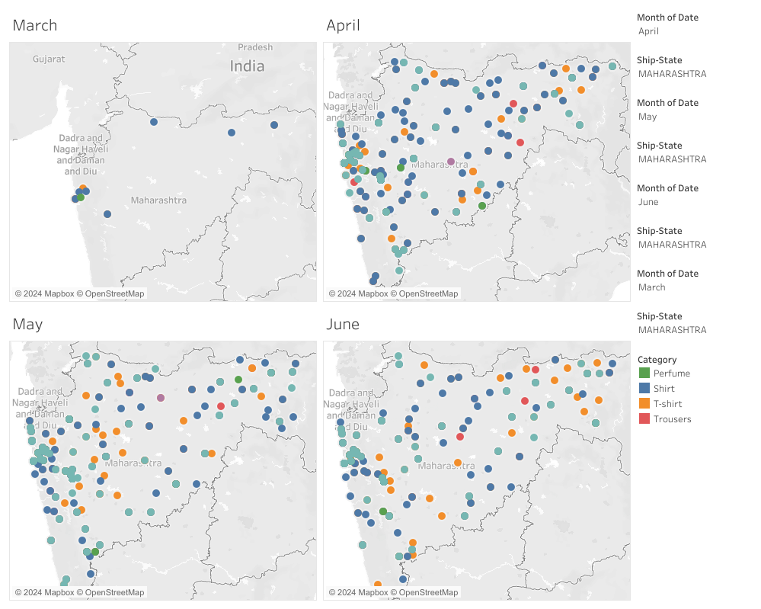

**10.2.Products sales in Karnataka**

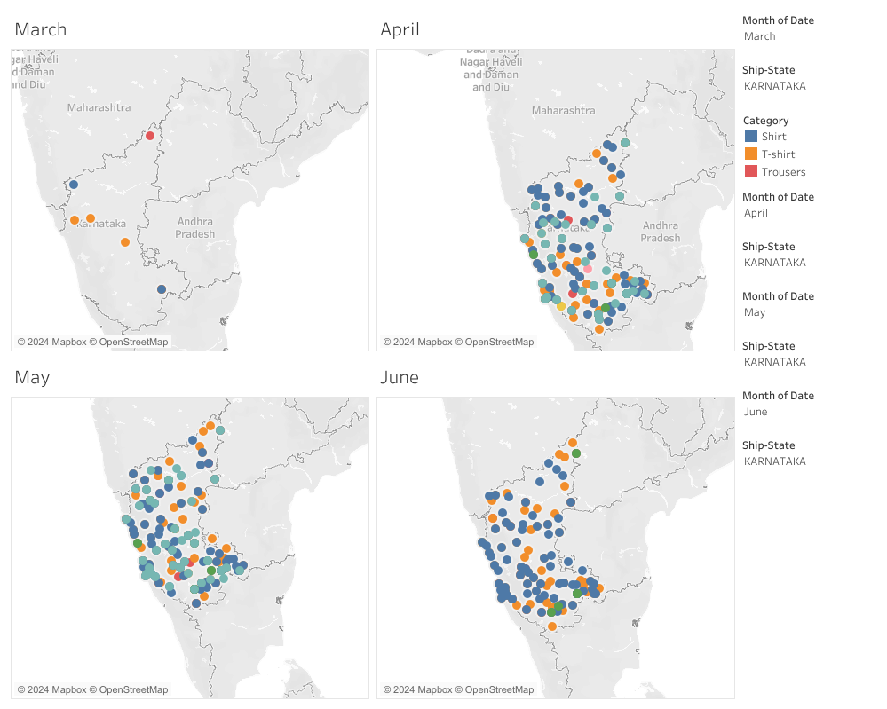

**10.3.Products sales in Tamil Nadu**

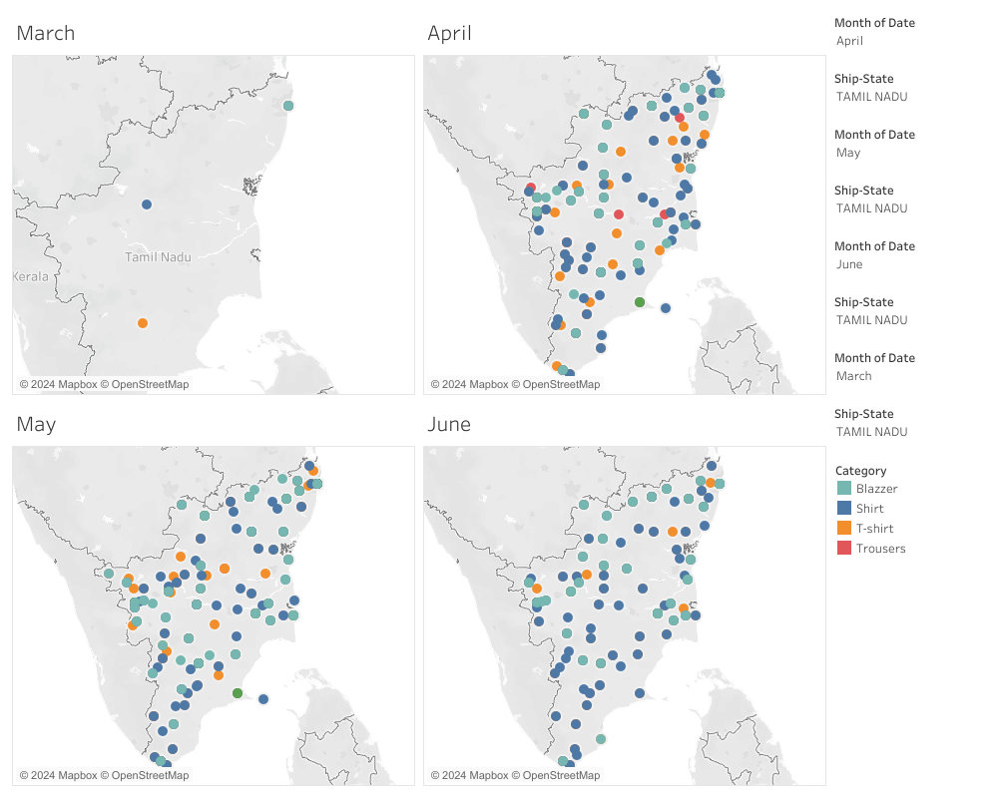

**10.4.Products sales in Telangana**

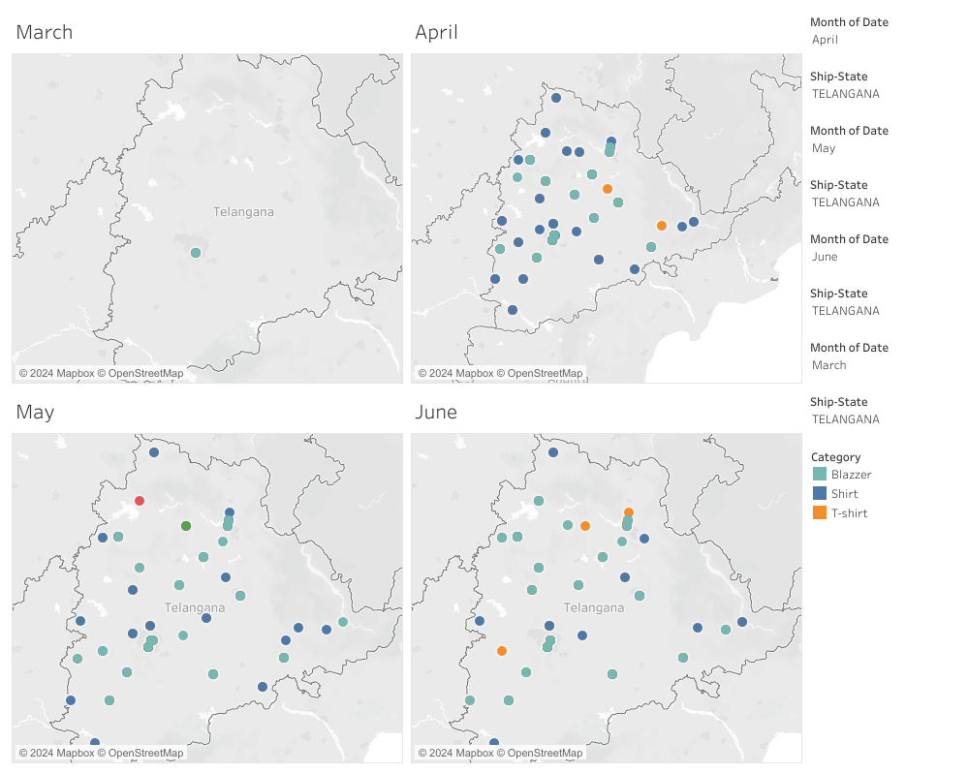

### ****Business Insights****

1. **Sales Strategy Optimization**:
   * **Trend-Based Promotions**: Identify peak sales periods and recommend targeted promotions during these times to capitalize on consumer demand.
   * **Product Bundling**: Suggest bundling popular products with slower-moving items to increase overall sales and reduce inventory of less popular items.
   * **Pricing Strategy**: Recommend dynamic pricing adjustments based on sales trends, competitor pricing, and product demand to maximize revenue.
2. **Product Management**:
   * **Inventory Optimization**: Based on sales data, recommend stocking higher quantities of fast-moving products while reducing inventory for slower-selling items to optimize inventory turnover.
   * **New Product Development**: Identify gaps in the product portfolio where demand is high but supply is limited, suggesting areas for new product development or expansion.
3. **Fulfillment Improvement**:
   * **Fulfillment Method Efficiency**: Analyze which fulfillment methods result in the highest customer satisfaction and lowest return rates, recommending a focus on the most effective methods.
   * **Order Processing Time**: Suggest improvements in the order processing and fulfillment cycle to reduce delivery times and enhance customer satisfaction.
4. **Customer Experience Enhancement**:
   * **Personalized Marketing**: Use customer segmentation data to recommend personalized marketing strategies, such as targeted email campaigns, to increase customer engagement and repeat purchases.
   * **Customer Loyalty Programs**: Develop or enhance loyalty programs targeting high-value customer segments to encourage repeat purchases and increase customer lifetime value.
   * **Customer Feedback Loop**: Implement a robust system for collecting and acting on customer feedback to continuously improve products and services, leading to higher customer satisfaction.
5. **Geographical Market Expansion**:
   * **Focus on High-Growth Regions**: Identify regions with strong sales performance and potential for growth, recommending targeted marketing efforts and resource allocation to these areas.
   * **Localized Product Offerings**: Suggest tailoring product offerings to regional preferences, identified through geographical sales analysis, to better meet local demand.
6. **Operational Efficiency**:
   * **Supply Chain Optimization**: Recommend streamlining supply chain operations based on sales and fulfillment data to reduce costs and improve delivery speed.
   * **Technology Integration**: Suggest adopting or enhancing technological solutions, such as automated inventory management or AI-driven customer service tools, to improve operational efficiency and reduce overhead.
7. **Revenue Growth Strategies**:
   * **Cross-Selling and Upselling**: Leverage insights from product and customer data to recommend effective cross-selling and upselling strategies during the checkout process or through follow-up communications.
   * **New Market Entry**: Based on geographical analysis, suggest potential new markets for expansion where demand is high but the company currently has low penetration.
8. **Customer Retention**:
   * **Churn Analysis**: Identify patterns in customer churn and recommend strategies to reduce churn, such as improved customer support, enhanced product quality, or more attractive loyalty rewards.
   * **Re-engagement Campaigns**: Develop strategies to re-engage inactive customers, such as personalized discounts or exclusive offers, to bring them back into the purchasing cycle.

### ****Recommendations****

* **Action Plan**: Outline a clear, step-by-step action plan for implementing the recommended strategies, including timelines, resource allocation, and expected outcomes.
* **Performance Metrics**: Establish key performance indicators (KPIs) to measure the success of the implemented strategies and ensure continuous monitoring and optimization.

**12 . CONCLUSION**

In this report, we conducted a comprehensive analysis of Amazon's sales data with the aim of providing actionable insights to support business decision-making. By meticulously examining various dimensions of the data, including sales performance, product categories, fulfillment methods, customer behavior, and geographical distribution, we have identified key trends and patterns that can inform strategic initiatives.

Our analysis revealed crucial insights into sales trends over time, highlighting peak periods and growth opportunities. Product analysis identified the most and least popular items, offering guidance for inventory management and product development. The examination of fulfillment methods provided a clear view of their effectiveness, suggesting areas for operational improvement. Customer segmentation uncovered valuable insights into purchasing behavior, allowing for more targeted marketing and personalized customer engagement strategies. Geographical analysis identified high-performing regions and potential growth markets, guiding regional marketing and sales efforts.

The recommendations derived from this analysis are designed to optimize sales strategies, improve customer satisfaction, and enhance overall business performance. By implementing these strategies, Amazon can better align its operations with market demands, enhance customer experience, and drive sustained revenue growth.

This analysis is a crucial step towards leveraging data-driven insights to make informed decisions, ensuring that Amazon remains competitive in the dynamic e-commerce landscape. The actionable recommendations provided in this report are tailored to address the specific challenges and opportunities identified, setting the stage for continued success and growth.